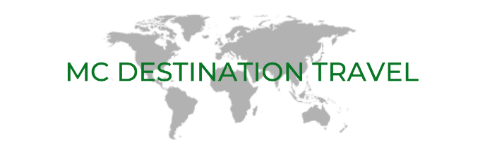

EGYPT AND JORDAN

Date: October 2 – October 18, 2020

Join us on this incredible journey as we visit the highlights of Egypt and Jordan. Extend your stay by adding a visit to Israel.

Option ISRAEL EXTENSION: October 18 - 24, 2020

Friday, October 2 Flight from Canada to Cairo, Egypt Meals in flight
Flight options are available upon request.

Saturday, October 3 Arrive in Cairo
Welcome to Egypt! Upon arrival, we will be met by a local representative and transferred to our hotel for the next two nights. The rest of the day is at our leisure to rest up after our long flight from Canada. Dinner is on our own—the hotel has several dining options. Our tour of Egypt will begin tomorrow morning.

Accommodation: Ramses Hilton Hotel for 2 nights (standard room)

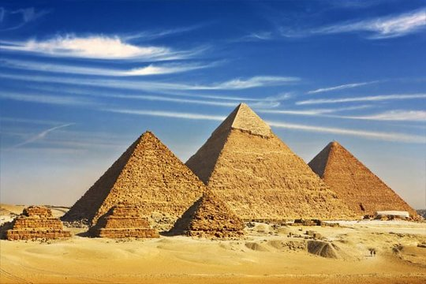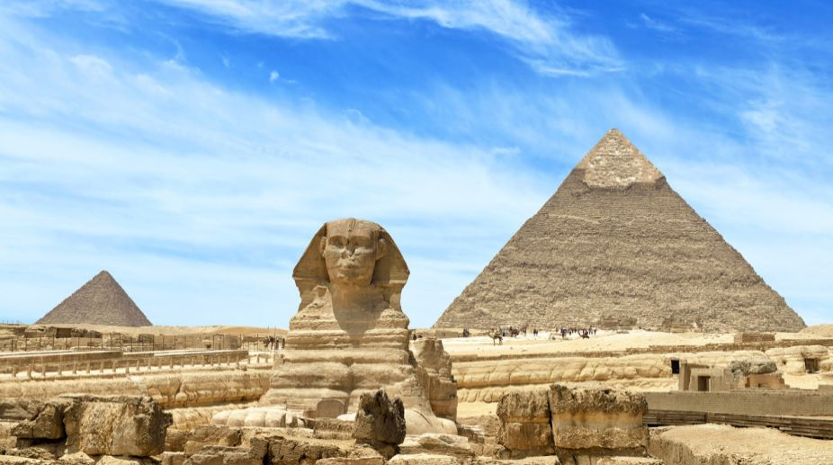
Sunday, October 4 Full Day Pyramids and Sphinx BLD
After breakfast at the hotel, the excitement begins this morning with a visit to the famous Cheop's Pyramid (Giza), one of the Seven Ancient Wonders of the World built over 35 centuries ago and the Sphinx. The towering pyramid stands majestically on a desert plateau together with two slightly smaller pyramids erected to preserve the bodies and treasures for the afterlife.

We will visit the Solar Boat Museum, that houses the spectacular funerary boats placed at the disposal of the King for his journey to the afterlife. Ancient Egyptians used to bury a "solar barge" near the tomb of their pharaoh because they believed that their ruler needed transportation in the afterlife. In 1954, the parts of a cedar-wood barge were found in five pits near the Great Pyramid of Khufu. The barge was restored and assembled out of 1200 pieces of wood and it is displayed, since then, in a glass museum near the Great Pyramid in Giza.

Then it's on to Memphis, the first capital of Egypt and Sakkara, the “City of the Dead” with its step pyramid of King Zoser. Lunch today will be served at Abu Shakra Restaurant.

Enjoy a welcome dinner tonight at a local restaurant (TBA).

Accommodation: Ramses Hilton Hotel

Monday, October 5 Fly Cairo to Aswan BD
After breakfast at the hotel we will check out and transfer to the airport for your domestic flight to Aswan. Flight details TBA. Upon arrival into Aswan, we will be met at the airport and transferred to the hotel.

Later, we will visit a Nubian Village & Soheil Island. Sail on the Nile by a motorboat to the Nubian Village on Soheil Island that is located on the West Bank of the River Nile in Aswan and near the Aswan Dam passing by the First Cataract of Aswan. This fantastic 3 hour tour to the Nubian Village lets you meet and impact with a Nubian family and learn about their simple life style, culture and traditions.

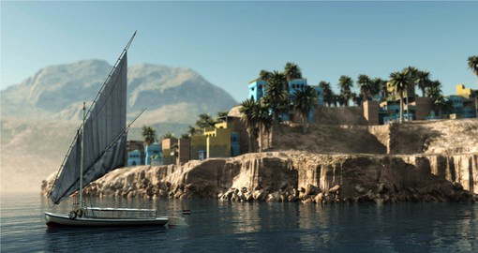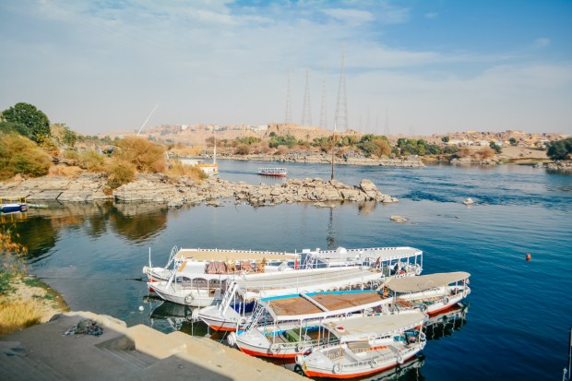

Nubians are an Ethnic group who live in the south of Egypt (Aswan) and the north of Sudan. The Nubian villages are located at the East or the West banks of the river Nile or as islands. Old villages used to be where Lake Nasser is now, and they were relocated in 1964 as a result of building the High Dam of Aswan.

First, the boat will sail on the Nile, which is very clear and smooth in Aswan, while you enjoy the view and the landscape of the natural reserve area, which consists of small islands (Saloga & Ghazal). Watching Sahara and sand dunes of the Western desert, the flowing water over the granite stone (the first cataract), flora and fauna of the area as well as birds especially migrant ones such as Herons, Egrets and King Fisher. While sailing, you will also have a chance to see very important sites as the Agha Khan Mausoleum and the ruins of the Elephantine Island.

Stop to walk through the village and see its traditional colorful houses built from mud brick, then visit a family and have a Nubian drink (mint tea or hibiscus tea) and have an idea about Nubian history, culture and nature. You can have a tattoo (henna) which is very traditional in Nubian weddings. And you may have a chance to see the famous Nile crocodile, which is very common in Lake Nasser. Then back by the boat watching more exciting villages on the way to the hotel.

Enjoy dinner at a local restaurant (TBA).

Accommodation: Movenpick Aswan for 1 night (standard room)

Tuesday, October 6 Nile Cruise Embarkation BLD
Today we board our Nile Cruise Ship—the Sonesta Moon Goddess, our floating hotel for the next five days.

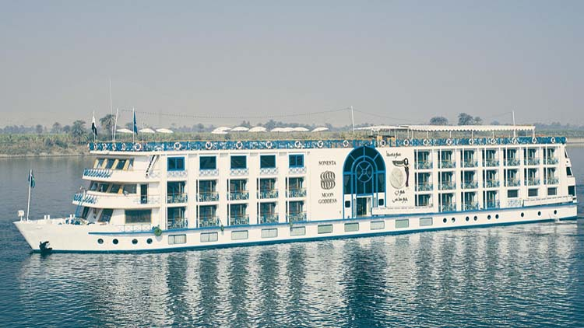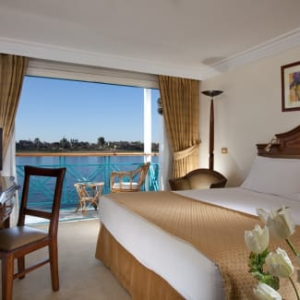

Aswan is the best winter resort in Egypt. On its eastern bank are mosques, bazaars, Ferial Gardens, Nubian Museum, Fatimid Cemetery, the Unfinished Obelisk of Queen Hatshepsut, Kitchener's Island and Elephantine Island, which is the largest in Aswan. As for its western bank there are tombs of local Pharaonic nobles and dignitaries, the tomb of Aga Khan, the Coptic Monastery of St. Simeon and the Old Aswan Dam. Enjoy a Nubian Folkloric Show and Dinner on board to end the night.

Accommodation: Sonesta Moon Goddess for 4 nights (deluxe cabins)

Wednesday, October 7 Kom Ombo and Edfu BLD
This morning we will visit the High Dam, the Granite Quarries and the Temple of Philae then sail to Kom Ombo where we will visit the temple shared by two gods Sobek and Haeroris in Kom Ombo.

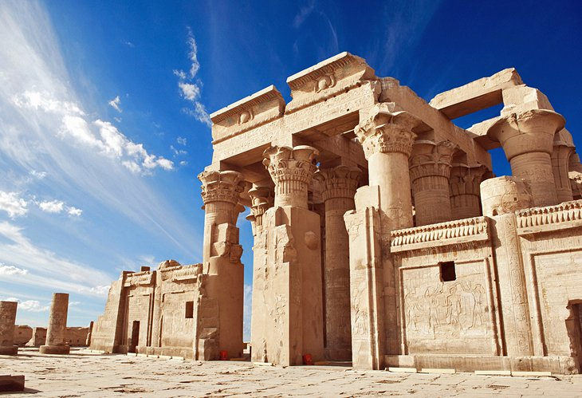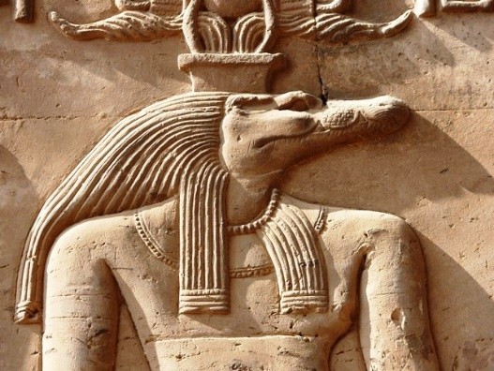

Located on the east bank, Kom Ombo is home to an unusual double temple built during the Ptolemaic and Roman periods. The temple is dedicated to the crocodile god Sobek and the falcon god Haroeris (Horus the Elder). Despite being badly damaged, the temple is a beautiful sight as one approach from either direction on the river, particularly as sunset nears and the colors change. Return to the vessel to sail to Edfu.

Enjoy a Captain’s Welcome cocktail before dinner on board.

Accommodation: Sonesta Moon Goddess

Thursday, October 8 Sail Esna to Edfu BLD
This morning you will visit the Horus Temple in Edfu then sail to Luxor. The Temple of Edfu is an Egyptian temple located on the west bank of the Nile in Edfu. The Temple of Horus is preserved by desert sand, which filled the place after the pagan cult was banned, the temple is dedicated to Horus, the avenging son of Isis and Osiris. With its roof intact, it is also one of the most atmospheric of ancient buildings.

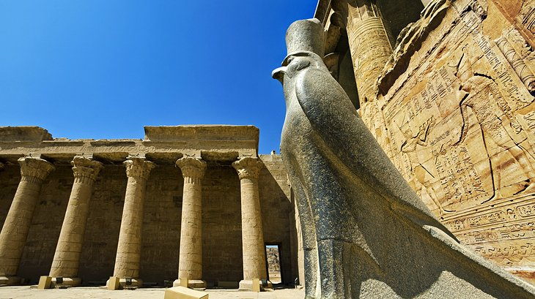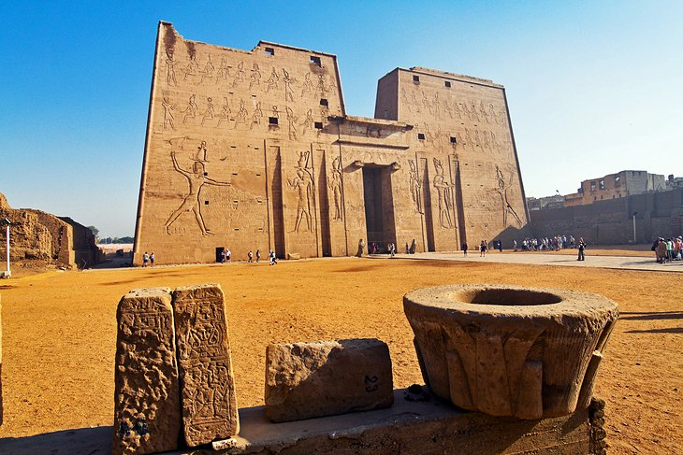

This evening enjoy a Galabya Party on board the ship after dinner. Guests are encouraged to wear a traditional galabya, which can be purchased on board the ship or from one of the vendors on shore. Purchase of a galabya is not compulsory to attending.

Accommodation: Sonesta Moon Goddess

Friday, October 9 Explore Luxor's East and West Bank BLD
After breakfast on board, you will visit the Valley of the Kings, the Temple of Queen Hatshepsut at El-Deir, El-Bahari and the Colossi Memnon. Luxor is a major attraction for tourists in Egypt. It is considered the world's largest open-air museum with its various temples since the Pharaonic era until the Greco-Roman era, most famous of which is Karnak and Luxor Temples dedicated to the triad of Thebes. The West Bank of Luxor is known for the famous tombs of Seti I, Tut Ankh Amon, Tuthmosis III in the Valley of the Kings and Queen Hatchepsut's Temple.

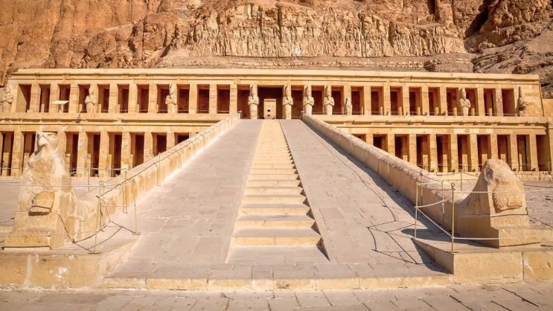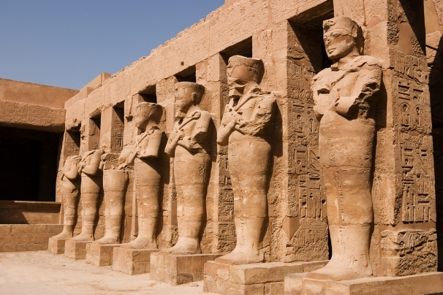

The Valley of the Kings in Upper Egypt is home to many pharaonic tombs of the New Kingdom, including those of King Tutankhamen and Ramses the Great. Each king's formal name and titles inscribed in his tomb, which is also adorned with his images and statues. Most of the tombs were cut into limestone following a similar pattern: three corridors, an antechamber, and a sunken sarcophagus chamber.

The mortuary temple of Queen Hatshepsut of the 18th Dynasty was built just north of the Middle Kingdom temple of Mentuhotep Nebhepetre, amid the bay of cliffs known as Deir El-Bahri. In ancient times the temple was called Djeser-djeseru, meaning the sacred of sacreds. The female pharaoh chose to build her temple in a valley sacred to the Theban Goddess of the west, on a direct axis with the Karnak Temple of Amun on the East Bank.
After lunch visit the Luxor Temple and Karnak Temples, a holy city of pylons (monumental gateways), hypostyle halls, colossal statues, shrines and obelisks built over centuries and dedicated to the God Amon-Ra, his consort Mut and their son Khonsu. Enjoy dinner and music on board this evening.

Accommodation: Sonesta Moon Goddess

Saturday, October 10 Today we fly from Luxor to Cairo BD
After breakfast we will disembark the cruise ship and transfer to the airport for your flight to Cairo. Flight details TBA. After our arrival into Cairo, we will then transfer and check in to the hotel. The remainder of the day is at our leisure to enjoy the hotel. Dinner will be at the hotel.

Accommodation: Ramses Hilton Hotel for 2 nights (standard room)

Sunday, October 11 Cairo Sightseeing BL
Today we visit the Egyptian Museum housing the greatest collections of Egyptian antiquity anywhere and includes the Mummy Room. It gives visitors remarkable insights into Egypt's ancient history. The priceless antiquities include King Tutankhamen's Treasures.

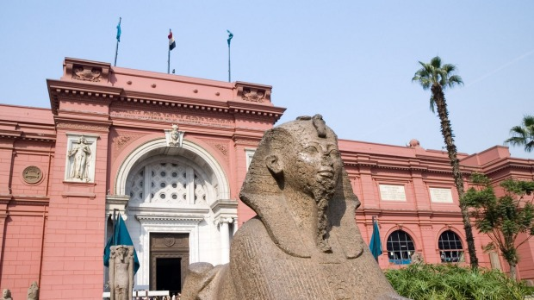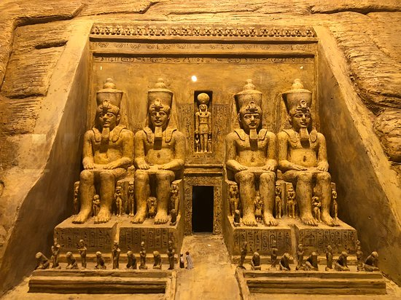

After lunch at a typical Cairo restaurant--Felfela Restaurant, it is time to explore Old Cairo with visits to some mediaeval mosques and churches, including the Citadel. We also enjoy a visit to Khan el Khalili Bazaar. The remainder of the day is at our leisure. Dinner is on our own (suggestions will be provided TBA). We are off to Jordan tomorrow.

Accommodation: Ramses Hilton Hotel

Monday, October 12 Fly Cairo to Amman, Jordan BD
After breakfast, you’ll be transferred to the airport for your flight to Jordan. Upon arrival we will be met and assisted with the transfer to the hotel. The rest of the day is at your leisure until we meet for a Welcome to Jordan this evening at Sufra Restaurant (dry/no alcohol).

Accommodation: Al-Qasr Metropole Hotel for 2 nights (superior rooms)

Tuesday, October 13 Amman to Jerash and Aljoun BD
After breakfast, we drive to visit the Roman city of Jerash visiting Maximus Cardo, the colonnaded street flanked by temples, churches, theaters &amp; endless mosaics. Continue to visit Aljoun Castle is an awe-inspiring Islamic fortress that withstood the power of the Crusader armies in the 12th Century.

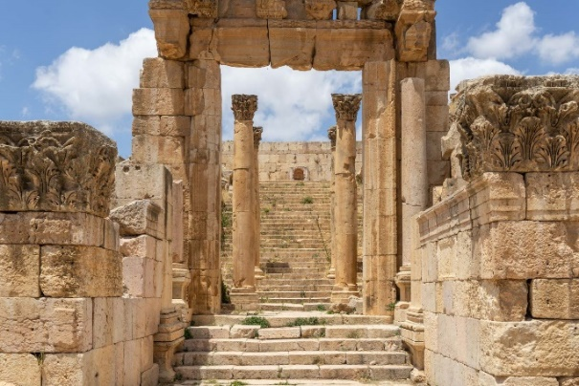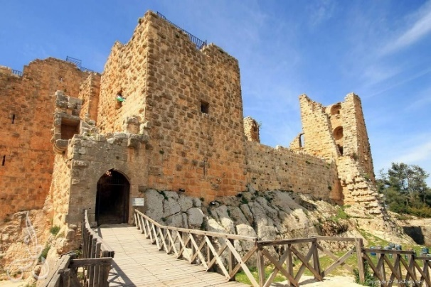

Climbing the narrow staircases and walking through endless hallways takes you back to a time of chivalry and faith, where you can almost imagine the sounds of battling Iron and the sight of the raging battlefield. Back to Amman for overnight. Dinner this evening is at Shams El-Balad Restaurant.

Accommodation: Al-Qasr Metropole Hotel

Tuesday, October 14 Amman to Petra BD
Enjoy breakfast at the hotel and then depart for Petra. Visit the endless churches of Madaba known as the city of mosaics for the famous mosaic map flooring the Greek Orthodox Church of St. George, the oldest map in the world depicting the Holy Land. Continue to visit Mount Nebo, the mountaintop memorial of Moses with captivating views of the Jordan Valley, Dead Sea, and River Jordan. We continue to Petra and check in to our hotel.

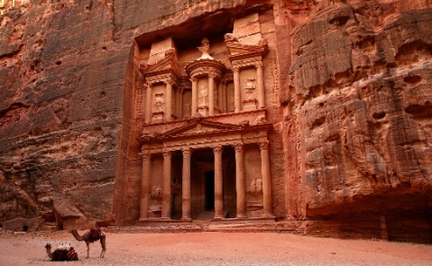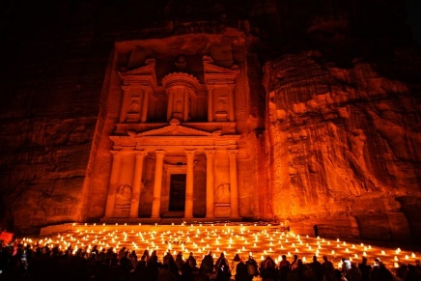

This evening we will enjoy Petra by Night. Stroll down the candlelit paths and through the Siq to enjoy the traditional Bedouin music, a short story and some Bedouin tea.

Accommodation: Movenpick Nabatean Castle Hotel for 2 nights (superior rooms)

Wednesday, October 15 Petra BD
After breakfast we have a full day dedicated to visit Petra the Rose Red City. The visit will include the main sites such as the "Siq", a long winding fissure between two walls of overhanging cliffs, the "Khazneh" referred to as the Treasury, the Street of Facades, the Court House and the Amphitheater. A short horse ride between the Petra site entrance and the Siq is included (800 meters).

Spend an evening at Petra Kitchen learning to make traditional Middle Eastern dishes such as baba ghanoush, fattoush and hummus. Then enjoy the fruits of your labors and take-home recipes of the dishes you helped create.

Accommodation: Movenpick Nabatean Castle Hotel

Thursday, October 16 Petra to Wadi Rum BD
After breakfast at the hotel we depart Petra and head to Wadi Rum, the most enchanting desert in the world. An open space and a setting that resembles that of the moon, Wadi Rum will engulf you with its enigmatic lure. We have arranged for a Closed Top 4X4 jeep tour for 2 hours inside the desert to visit Lawrence Spring and Khazalee Mountain. After, you’ll be transferred to your tented desert camp for dinner and overnight.
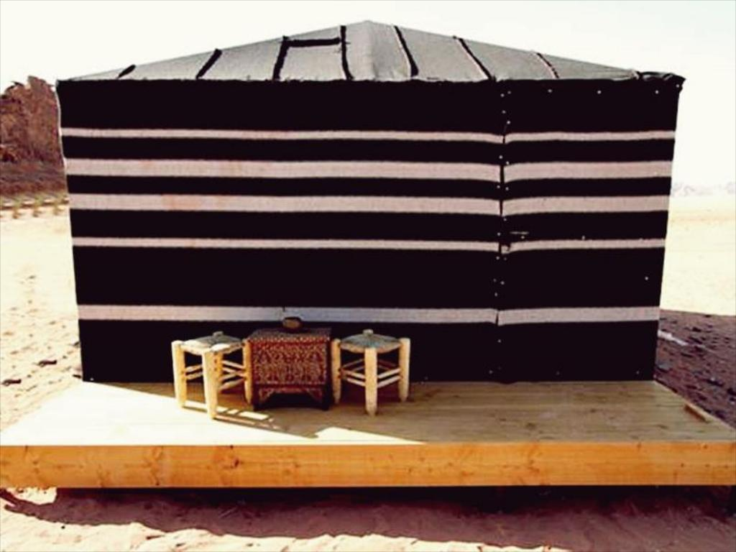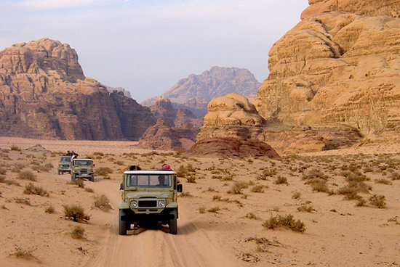

Accommodation: Sun City Camp Wadi Rum for 1 night (deluxe tents with private facilities; dry/no alcohol)

Friday, October 17 Wadi Rum to Amman B
After breakfast we return to Amman (approx. 4 hour drive). Check into our next hotel and then enjoy an afternoon walking tour of Amman City to include the visit of the citadel. Return to the hotel for overnight.

Accommodation: Al-Qasr Metropole Amman Hotel (superior rooms)

Saturday, October 18 Return flight to Canada B, Meals in flight
Our Jordan tour ends today.

ISRAEL OPTION:
Saturday, October 18 Amman to Tiberias BD
Today we cross over the border from Jordan at the King Hussein (Allenby) Bridge and arrive in Israel. We will drive to Nazareth to visit the Basilica of the Annunciation. Visit the Blessed Cave the site where the Angel Gabriel appeared to Mary. View Mary and Joseph's house. We drive to visit Cana, the site of Jesus' first miracle to arrive in Tiberius on the Sea of Galilee.

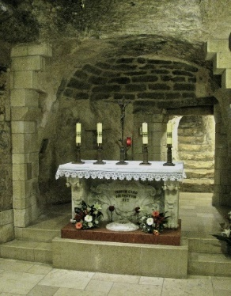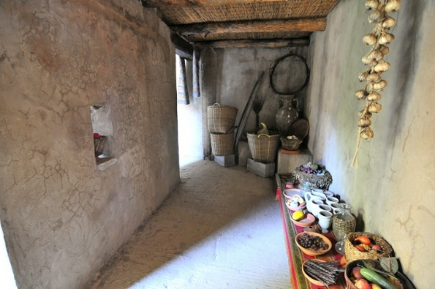

After dinner you will be taken to the Hamat Gader Hot Springs for free time to enjoy the mineral springs baths.

Accommodation: Leonardo Tiberius or similar for 2 nights

Sunday, October 19 Sea of Galilee BLD
We start with a scenic cruise on the lake and then visit the Mount of Beatitudes, the site of the multiplication of loaves and fish. We also visit Capernaum and continue to the Golan Heights and a winery to sample local wines.

Lunch is included at a local kibbutz. This evening we will have an interesting stop at a typical Kibbutz to learn about the way of life there including dinner.

Accommodation: Leonardo Tiberius

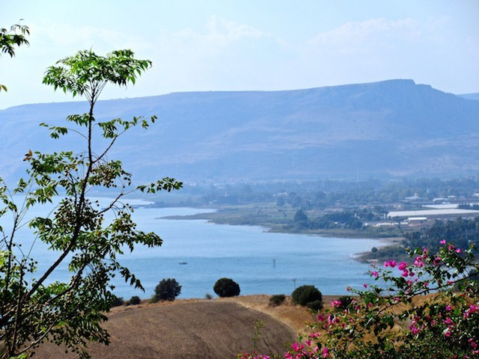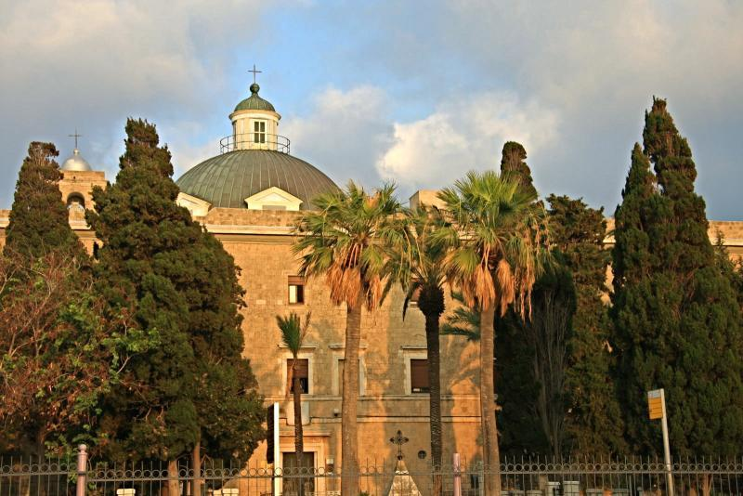

Monday, October 20 Haifa and Tel Aviv BD
Today we will drive to a Druze village on the top of Mount Carmel to learn about this special community. We will drive to the port of Haifa and continue south to the resort of Caesarea. We drive down the coast to Tel Aviv. There will be a short tour of the city including the interesting Bauhaus buildings. We drive the short distance to the old city of Jaffa for a walk around the old square. We will then continue to Jerusalem for check in to our hotel and dinner at the hotel.

Accommodation: Leonardo Jerusalem for 4 nights

Tuesday, October 21 Dead Sea, Masada and Qumran BD
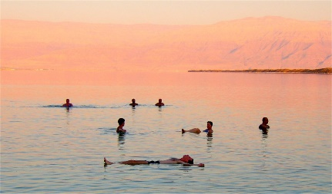
Descend through the Jordan Valley towards the shores of the Dead Sea. Arrive at Masada, the last outpost of the Jewish Zealots, who committed mass suicide rather than surrender to the Romans in the 1st century.

Free time at the Dead Sea with the opportunity to float on the salted water. Then continue to Qumran where the Dead Sea Scrolls were found. Stop at Jericho, the world's oldest city. Close by; view the Mt. of Temptation where Jesus was tempted. Dinner is included at the hotel.

Accommodation: Leonardo Jerusalem

Wednesday, October 22 Old City Jerusalem BD
Ascend the Mount of Olives to marvel at the spectacular view of the Holy City of Jerusalem. Walk down the hill the Church of Pater Noster and the Chapel of Ascension. On to the church of Dominus Flevit and the Church of All Nations in the Garden of Gethsemane where Jesus endured his agony. Descend across the Valley of Kidron. Continue to Mt. Zion, just outside the City Walls, to view the Church of St. Peter in Gallicantu, where the Apostle denied Jesus three times. Visit Room of the Last Supper King David's Tomb and the Church of the Dormition from which place Blessed Mary assumed to heaven.

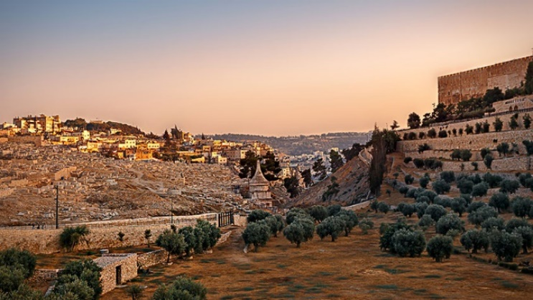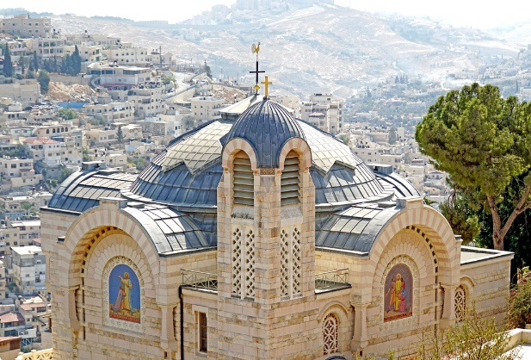

Accommodation: Leonardo Jerusalem

OPTIONAL: In the evening, you can enjoy an optional sound and Light show at the Wall. CAD$35.00 per person (entrance only)

Thursday, October 23 Israel Museum, Yad Vashem and Bethlehem BLD
Today we start with a visit to the renowned Israel Museum which houses the Shrine of the Book and the Second Temple followed by Yad Vashem, the Holocaust Memorial.
Later we drive the short distance to Bethlehem and visit the Church of the Nativity.

After lunch there will be time for shopping and exploring. The afternoon is at leisure. We will meet this evening for our Farewell to the Middle East dinner at an atmospheric local restaurant.

Accommodation: Leonardo Jerusalem
Friday, October 24 Return to Canada B, Meals in flight
Today we transfer to Tel Aviv airport for our return flight home.

*While it is our intention to adhere to the route described above, there is a certain amount of flexibility built into the itinerary. Due to traffic or other unforeseen events on occasion it may be necessary, or desirable to make alterations. We reserve the right to change the itinerary when deemed necessary or desirable.

Tour Cost:
Egypt and Jordan: $6590 per person, shared basis
Israel Extension: $4950 per person, shared basis

Deposit due of $750 CAD at time of booking.
Final payment will be due by July 17, 2020.

Included in the tour cost:
- First class accommodations as per the itinerary on a shared basis
- All transfers and transportation is by private, air-conditioned coach with driver/guide
- Arrival meet and greet guide assistance, departure guide assistance
- English-speaking guides throughout
- Sightseeing and admissions as per the itinerary
- Local taxes on accommodation and sightseeing tours
- Meals as indicated on itinerary (B-Breakfast, L-Lunch, D-Dinner)
- Domestic flights Cairo to Aswan / Luxor to Cairo
- Jordan Visa (copy of passport page required)
- Hotel and airport porterage in Jordan, Egypt and Israel
- Porterage on cruise ship in Egypt
- Headsets in Israel
- Water bottle

Not included in the tour cost:
- International airfare, taxes and fuel surcharges, seat selection
- Items of a personal nature (laundry, etc.)
- Meals unless stated in itinerary
- Tips and gratuities (guidelines will be provided)
- Visa and passport handling fees for Egypt and Israel
- Emergency travel insurance

*rate is based on minimum 12 passengers traveling
*rate is subject to currency fluctuation

FYI! Payment schedule can be arranged with Uplift.

